**Daily Scrum or Standup Meeting**

Team name: 5th Element

Scrum Master: Leonardo Craven

Date: November 3, 2021

| **Team Member** | **What did you do since the last scrum?** | **What do you plan to do before the next scrum?** | **What obstacles do you have?** |
| --- | --- | --- | --- |
| Leo | Finished scorecard page | Work on edit drink menu page (done by Thursday)  Resolve issues with scorecard page | None |
| Gavin | Finished leaderboard page | Work on manage drink orders page (done by Friday)  Resolve issues with scorecard page | None |
| Andrew  (not present at meeting) |  |  |  |
| Brock | Worked on add money page | Work on add money page (finish by Thursday) | None |

# Burndown

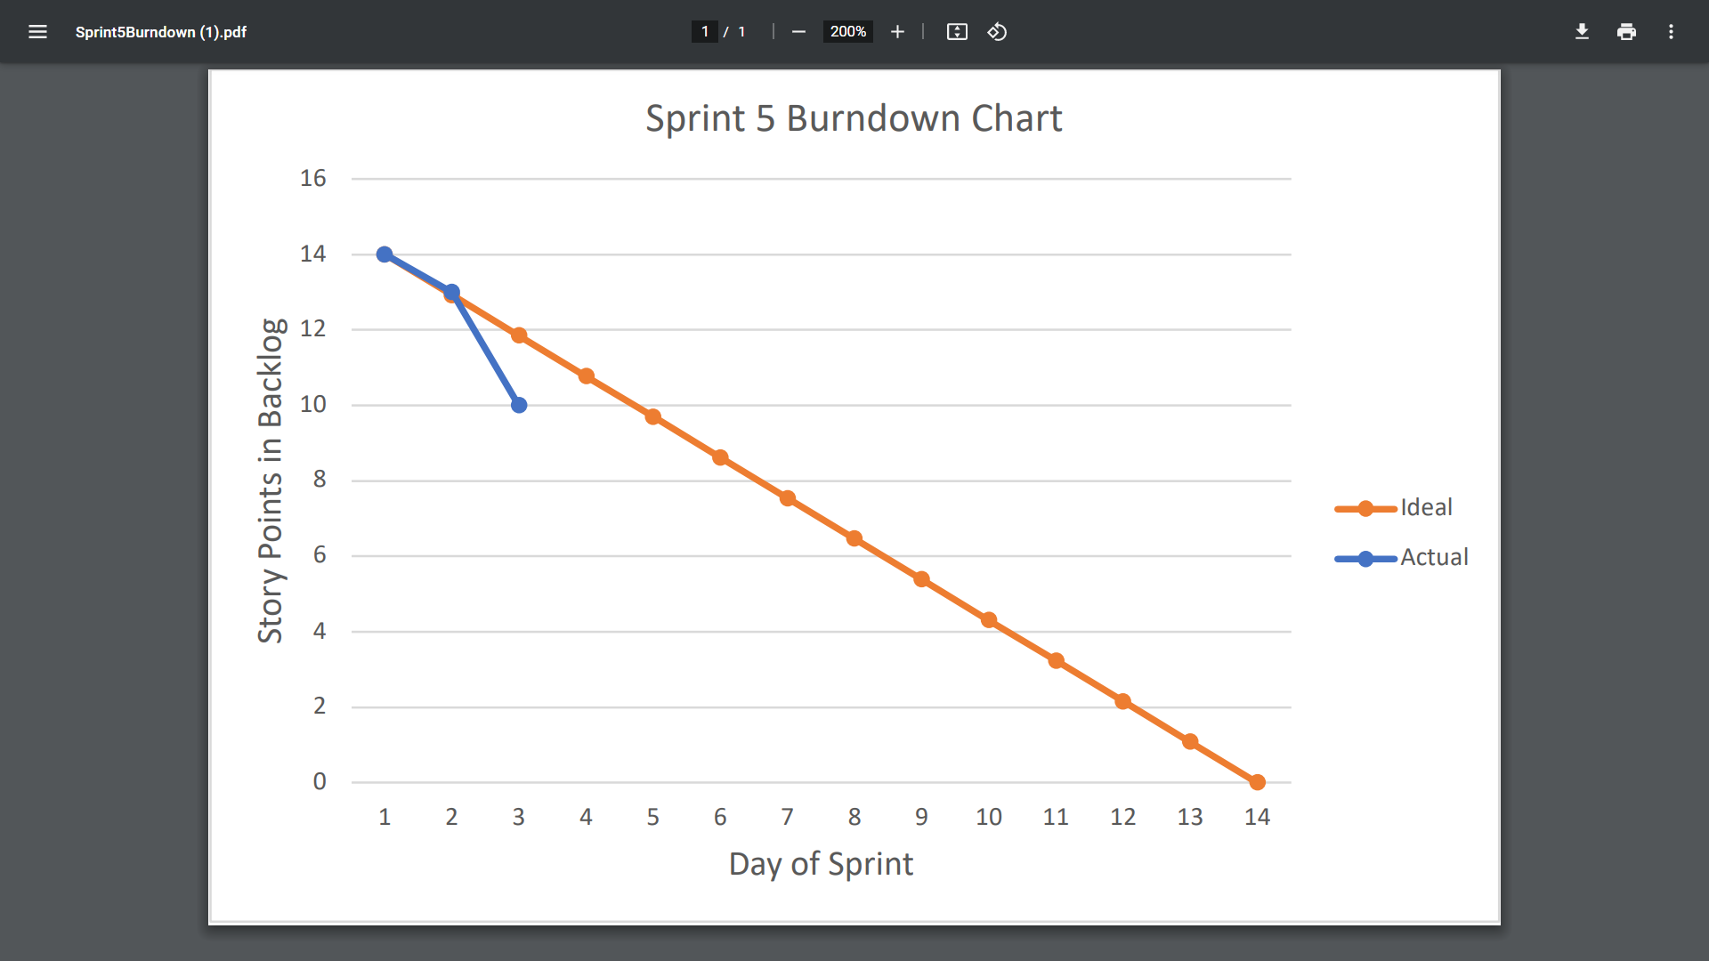

# Screenshot of you project board

